Format pour les articles soumis à SFE 2023
Paper Format for the SFE 2023

A. B. Surname¹, C. D. Surname²
¹Department of Electrical Engineering, University of Orthanc, Isengard
²Department of Power Engineering, University of Hobbiton, Shire

Abstract— The abstract should not be more than 400 words in length. After the review is completed, the authors must submit the final manuscript using this format. A4 page size of 210 mm × 297 mm (8.27" × 11.69")
Page margin: top and bottom 25 mm, right and left 20 mm
Times new roman,

Keywords—Fonts, formatting, margins

I. INTRODUCTION

Page limit of the regular papers is from 2 to 6 pages. Use this template to write your conference paper in English or in French.

II. METHODOLOGY

- Type sizes and typefaces
Corresponding author: name
e-mail address:

Use 14 point bold, capital letters for the title, 12 point Times New Roman (normal) characters for author information and for the main text.

- Format:

In formatting your page, set top and bottom margin to 25 mm. Left and right margins should be 20 mm. Use a two-column format.
Left and right-justify your columns. Use tables and figures to adjust column length. Use automatic hyphenation and check spelling. All figures, tables, and equations must be included in-line with the text. Do not use links to external files.

III. RESULTS

A. Figures and Tables

For printed journal, colored manuscript is printed with B&W, but in the web version colored graphs and tables can be used.

Table I
Type sized for camera-ready papers

Type Size (pts) | Appearance
 | Regular |  |  | Bold | Italic
10 | Table captions
 | Section titles, tables, table names , table superscripts, figure captions, text subscripts and superscripts,  footnotes  Abstract |  |  |  | Sub-heading
9 | references,
12 | Authors’ name, affliations, main text, equations,
14 |  |  |  | Paper-title

Large figures and tables may span across both columns. Figure captions should be below the figures; table names and table captions should be above the tables. Use the abbreviation “Fig.” even at the beginning of a sentence.
Figure axis labels are often a source of confusion. Try to use words rather than symbols.

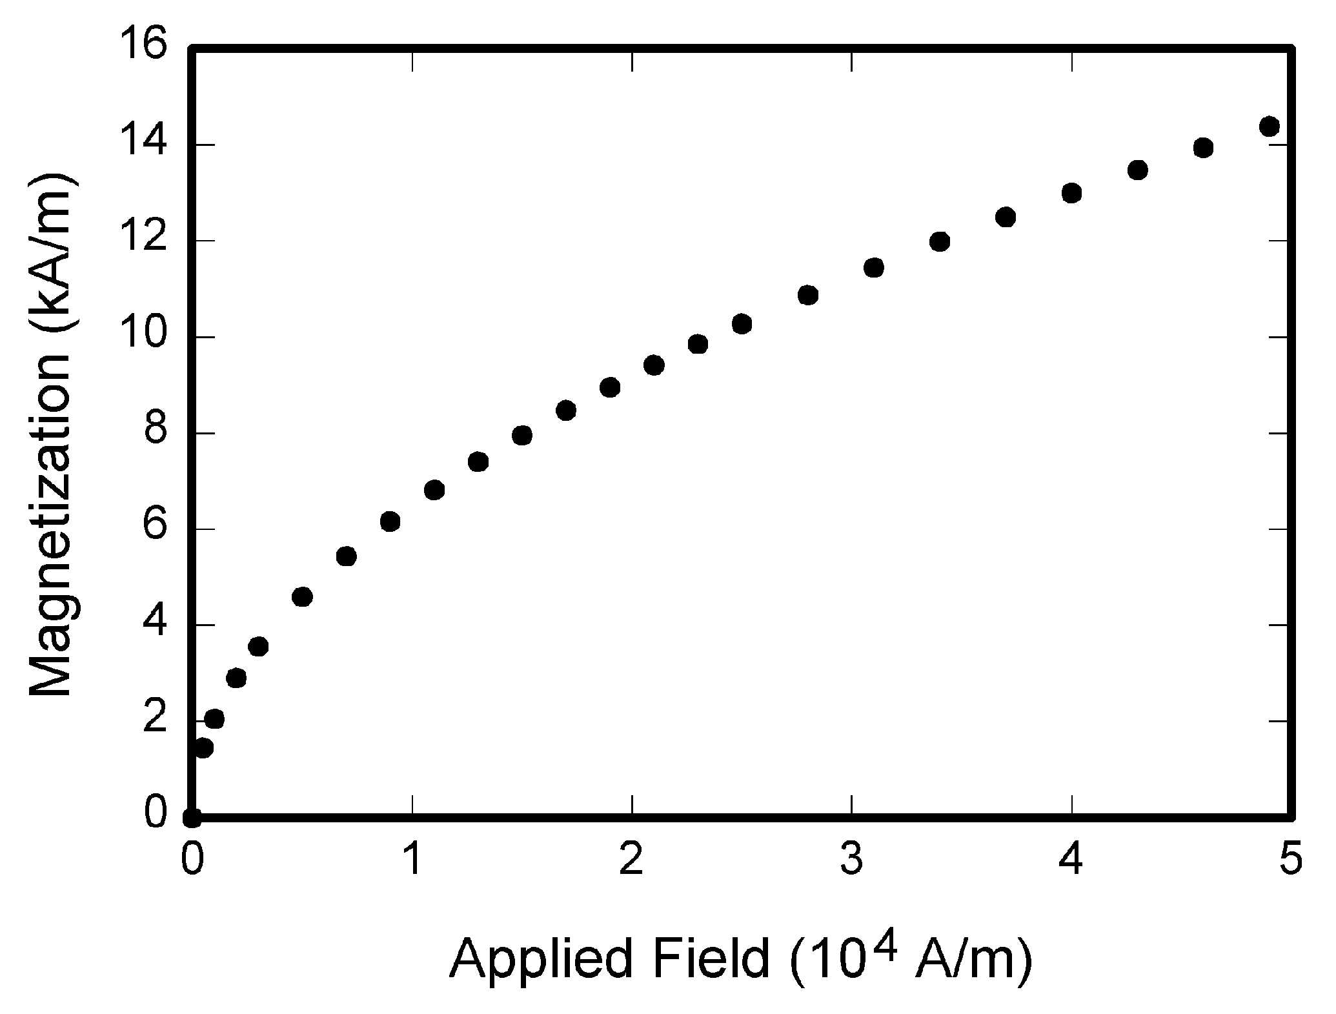

Fig. 1. Magnetization vs. applied field.

Note how the caption is centered in the column.

Figure labels should be legible, approximately 10-point type.

B. References

Number citations consecutively in square brackets [1]. The sentence punctuation follows the bracket [2].
Please note that the references at the end of this document are in the preferred referencing style.

C. Abbreviations and Acronyms

Define abbreviations and acronyms the first time they are used in the text, even after they have already been defined in the abstract. Abbreviations such as IEEE, SI, MKS, CGS, ac, dc, and rms do not have to be defined.

D. Equations

Number equations consecutively with equation numbers in parentheses flush with the right margin, as in (1). To make your equations more compact, you may use the solidus ( / ), the exp function, or appropriate exponents.

A + B = C (1)

Be sure that the symbols in your equation have been defined before the equation appears or immediately following.

E. Other Recommendations

The Roman numerals used to number the section headings are optional. If you do use them, number INTRODUCTION, but not ACKNOWLEDGMENT and REFERENCES, and begin Subheadings with letters. Use one space after periods and colons. Hyphenate complex modifiers: “zero-field-cooled magnetization.”

IV. DISCUSSION

Use either SI (MKS) or CGS as primary units. (SI units are strongly encouraged.)

V. CONCLUSION

ACKNOWLEDGMENT

Use the singular heading even if you have many acknowledgments. Sponsor and financial support acknowledgments are placed in the unnumbered footnote on the first page.

REFERENCES
- D. J. Beebe, “Signal conversion (Book style with paper title and editor),” in Biomedical Digital Signal Processing, W. J. Tompkins, Ed. Englewood Cliffs, NJ: Prentice-Hall, 1993, ch. 3, pp. 61–74M. Akay
- M. Akay, Time Frequency and Wavelets in Biomedical Signal Processing (Book style). Piscataway, NJ: IEEE Press, 1998, pp. 123–135
- G. B. Gentili, V. Tesi, M. Linari, and M. Marsili, “A versatile microwave plethysmograph for the monitoring of physiological parameters (Periodical style),” IEEE Trans. Biomed. Eng., vol. 49, no. 10, pp. 1204–1210, Oct. 2002.
- V. Medina, R. Valdes, J. Azpiroz, and E. Sacristan, “Title of paper if known,” unpublished.
- E. H. Miller, “A note on reflector arrays (Periodical style Accepted for publication),” IEEE Trans. Antennas Propagat., in press.
- T. Menendez, S. Achenbach, W. Moshage, M. Flug, E. Beinder, A. Kollert, A. Bittel, and K. Bachmann, “Prenatal recording of fetal heart action with magnetocardiography” (in German), Zeitschrift für Kardiologie, vol. 87, no. 2, pp. 111–8, 1998.
- J. E. Monzon, “The cultural approach to telemedicine in Latin American homes (Published Conference Proceedings style),” in Proc. 3rd Conf. Information Technology Applications in Biomedicine, ITAB´00, Arlington, VA, pp. 50–53.
- F. A. Saunders, “Electrotactile sensory aids for the handicapped (Presented Conference Paper style),” presented at the 4th Annu. Meeting Biomedical Engineering Society, Los Angeles, CA, 1973.
- J. R. Boheki, “Adaptive AR model spectral parameters for monitoring neonatal EEG (Thesis or Dissertation style),” Ph.D. dissertation, Biomed. Eng. Program, Univ. Fed. Rio de Janeiro, Rio de Janeiro, Brazil, 2000.
- J. P. Wilkinson, “Nonlinear resonant circuit devices (Patent style),” U.S. Patent 3 624 12, July 16, 1990.
- O. Yanez, private communication, May 2002.
- IEEE Criteria for Class IE Electric Systems (Standards style), IEEE Standard 308, 1969.

